Massimo Presciutti – H.U.M.A.N. BEING

H.U.M.A.N. BEING
Comenius Project LLP
Humour Universe Magnanimity Autonomy Novelty

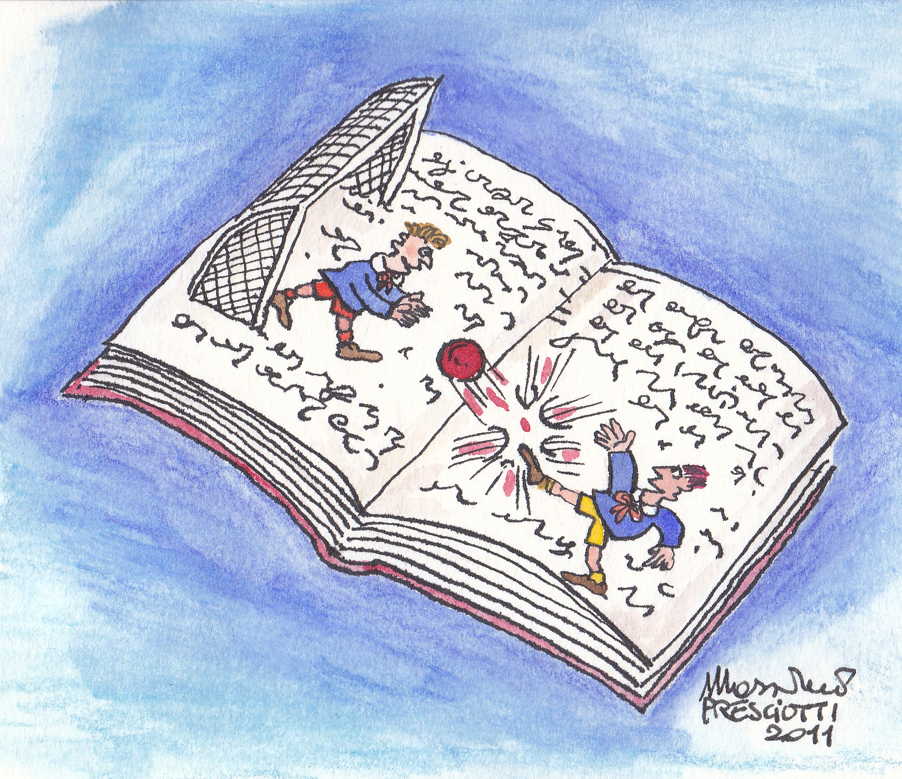
La versione italiana del presente articolo è stata pubblicata dalla rivista “Education 2.0”
I disegni dell’Autore sono stati pubblicati dal settimanale murale
di Berlinghiero Buonarroti “Il sabato del villaggio”

Adolescent Europe

My history with Europe it’s a personal history, a private question, I’m discommoding the Italian writer Bebbe Fenoglio (Alba 1922 – Torino 1963) because his book title (Una questione private / A private question) is too much beautiful and shocked me when I was boy, when a scale like that was considered, at the time, also by myself, at least out of style. Till April 1998, when I undertaken the travel to Wales, in Pontypridd, for a conference dedicated to the Primary Schools to sow seeds for a development of Comenius Projects, my teacher’s work achieved an achievement determined by different considerations:

- through a internal Projects to the Institutes where I worked I could develop my drawer and singer-songwriter’s for children activity;
- the local Institutions and mass – media had a certain attention to my work, that on the other hand was published by handmade little books (made in industrial way) making use of tools and trade of the monthly magazine’s desk where I collaborate in the past;
- the users assessed more and more a cultural inheritance, whose felt protagonist and repository, both the songs and consequent teaching methodology;
- the School World assessed a resource this kind of innovation. “(…) I had the chance to meet a young teacher, Massimo Presciutti, in which person saw again myself absolutely (…)”(Luigi Paternostro, FARONOTIZIE.IT, anno V, n. 50, Luglio 2010).

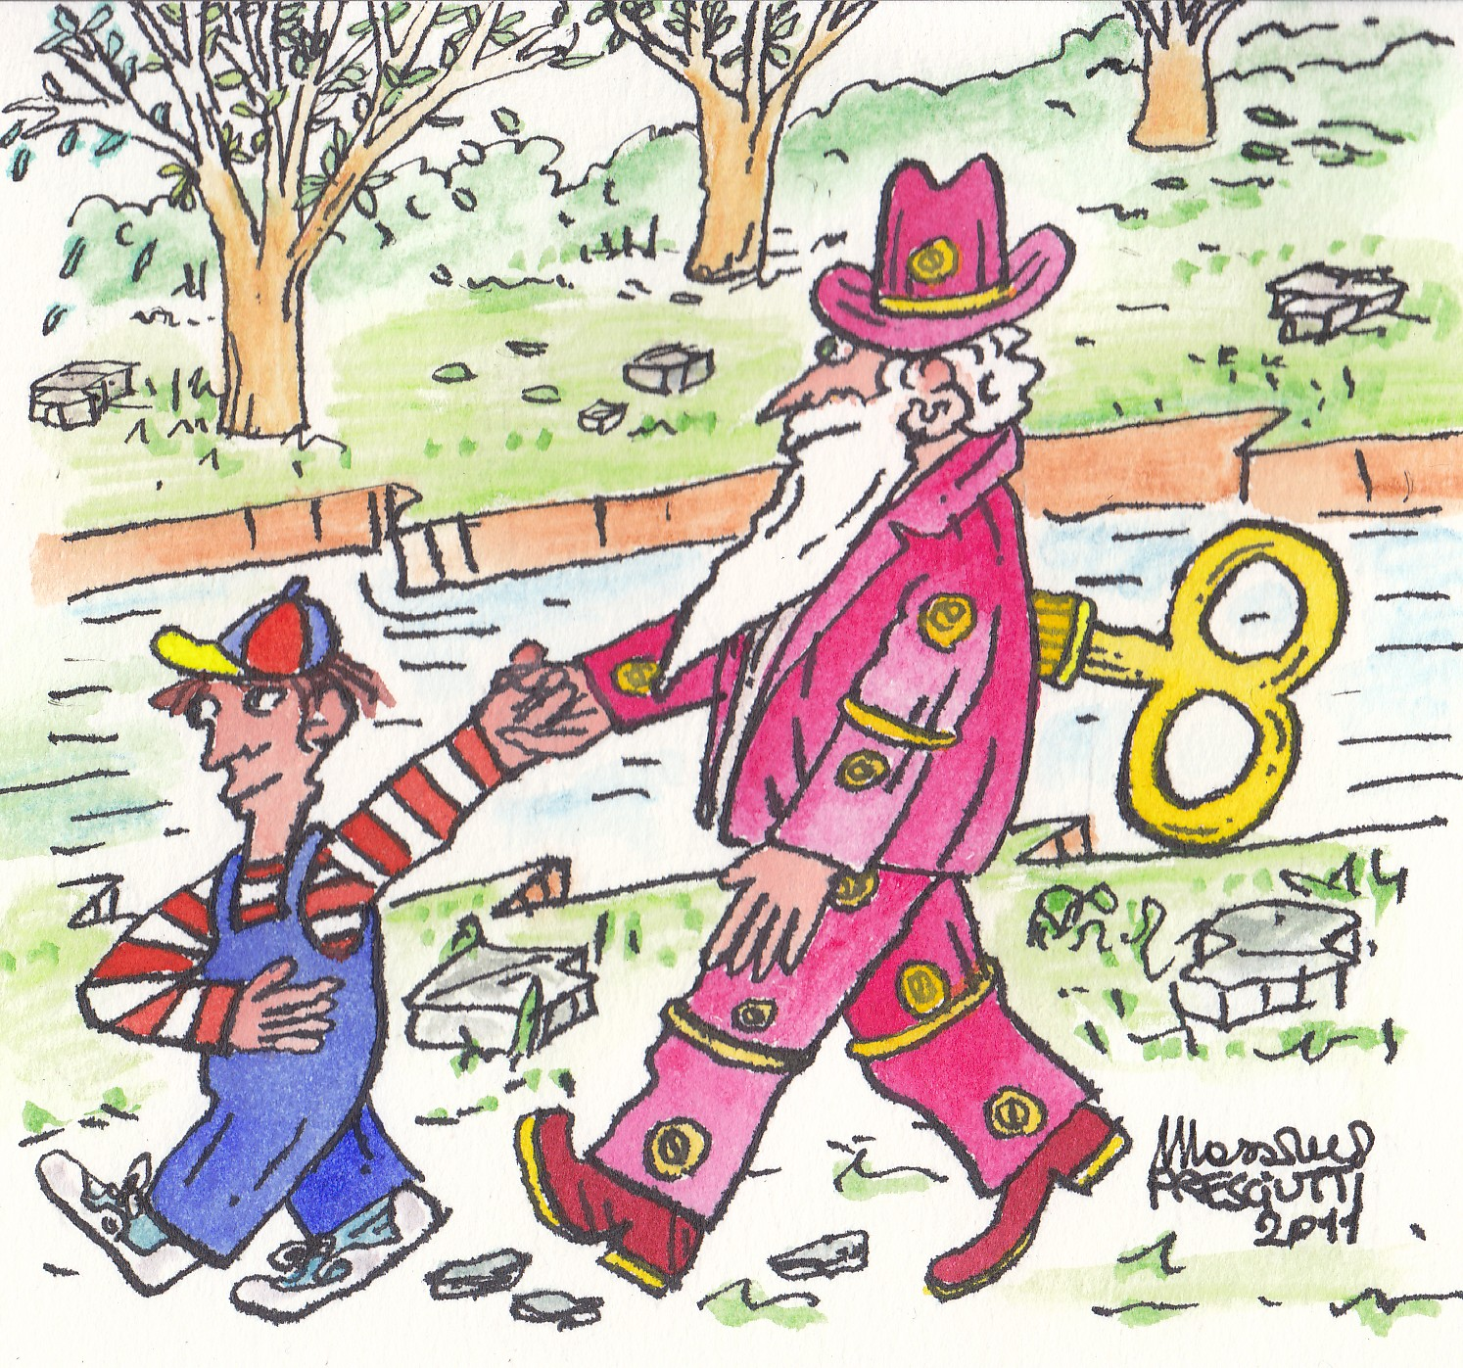

Totally lacking about the English language I could the same to do group thank to my scratch book where I drawn impressions, to the a night at pub to play guitar jointly organizers and European onlookers at meeting and to aid of the Italian group being with me (at first the staff on mission of our National Agency). I was quite recognized, by young Austrian, Danish and Grecian teachers, like Coordinator of a Comenius Project invented during one among the gastronomic break having under our’s eyes my printed little books of songs and drawings. The title, very explicative, was out at once: “Linguistic Adventures” (1999 – 2002). They will be produced, inter alia, a papery magazine, translated also in Austrian language, and my first musical CD, whose first edition, even if showed like industrial product, in reality was made Copy after Copy and the sleeve printed at my PC. I remember with a sense of nostalgia my little daughters browsing in my box room converted to a bizarre laboratory. When I made the first edition of 500 copies and the parcels arrived at home the smaller daughter said: “I understand daddy that you take care very much to these… if one breaks you can take another”. Actually the musical CD, produced by myself with the economic cooperation and the Project’s authorship, by S.I.A.E. (Italian Society of Author and Editor), was placed in a bookshops with success, as far as I am concerned, more than satisfying. Through part of grant amounts I followed the British Institute of Florence where I acquired a certain command of English language enough to write the future Projects in open solitude. An other acquired tool was, in the meantime, the computer use, becoming more and more the fundamental tool. The second Partnership, “Art of living” (2003 – 2006), in fact, have the features offering by information science: availability, filing, diffusion. The involved countries was Austria, Bulgaria and Spain.
Henceforth the style, method and contents, taking a recognizable shape, became object of an attention, from some European School Institutions, increasing a development by now identifiable and recognizable through the following Comenius, “Happy S.C.I.E.N.C.E.” (2009 – 2011) and the current “H.U.M.A.N. BEING “ (2011 – 2013). The way can be red like this: acquisition of tools with emotional mode, stay together finding our own dimension, scientific approach, individual human being value so an adult democracy can be only a combination of every single person.

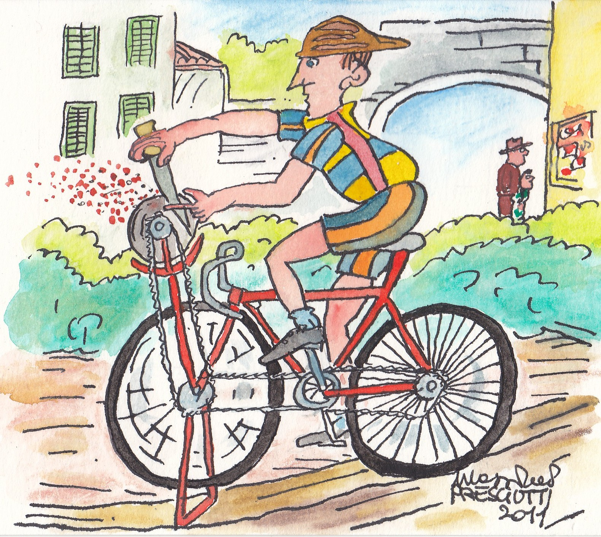

Massimo Presciutti, Florence 2011 November 9th

