The Creativity is the peculiar way of the Art and the Science. It is a matter of anything linked to the five senses, that never can’t be shared if not through a feeling whose limit is maybe the visionary madness in the Erasmian broad sense of the term. It is significant that among the intuition deeper of the French Revolution (Freedom, Equality, Fraternity) it is the first copyright act (1791). The feelings and the visionary madness are in an endless evolution because they concerned an human beings real live who are living, changing, dying. The Creativity can’t be related to the concepts like the quantity, goodness, common opinion. But being anything of specifically human, the Creativity get a soul, or better a memory making the past not static but subject to the constant changing in proportion to the evolutions of the present time. Consequently in the same time where it targets a second purpose, the Creativity isn’t like that and it become anything else relating to the political and religious of the society. by Massimo Presciutti

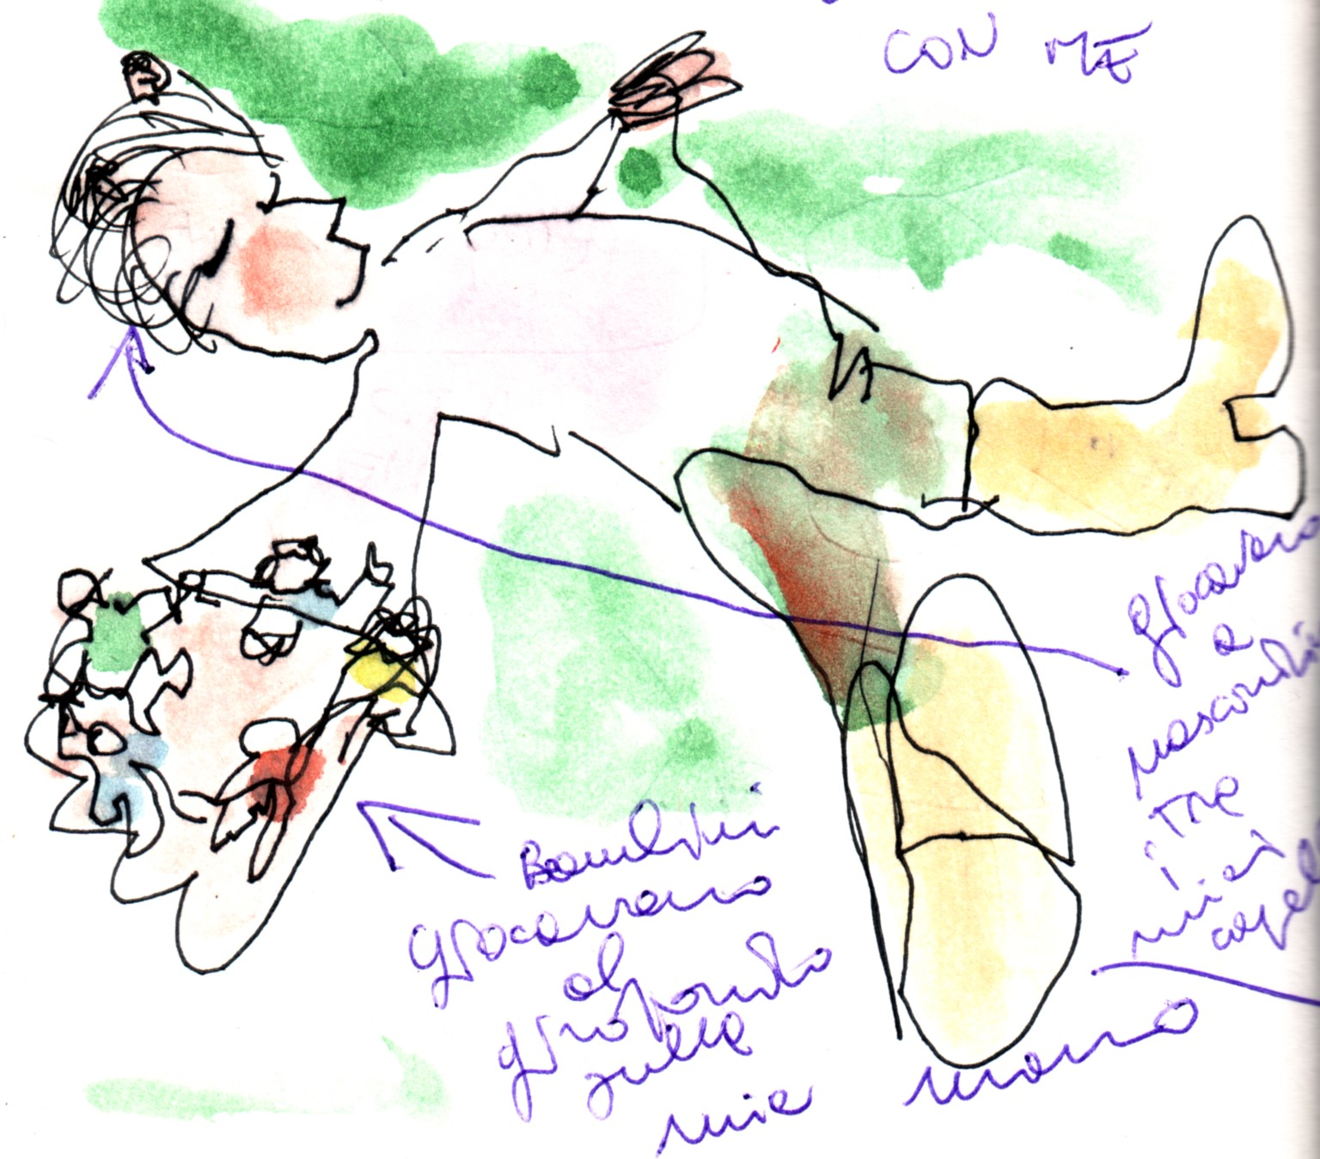

La Creatività è propria dell’Arte e della Scienza. Si tratta di qualcosa di collegato ai cinque sensi, che non possono essere mai condivisi se non attraverso una passione il cui limite è forse la follia visionaria nel senso erasmiano del termine. È significativo che tra le intuizioni più profonde della Rivoluzione Francese (Libertà, Uguaglianza, Fraternità) ci sia la prima legge sul diritto d’autore (1791). Affetti e follia visionaria sono in continua evoluzione perché riguardano esseri umani in carne ed ossa i quali nascono, cambiano, muoiono. La Creatività non può essere rapportata a concezioni come la quantità, la bontà, l’opinione corrente. Essendo però qualcosa di specificatamente umano, la creatività ha un anima, ovvero una memoria che rende il passato non statico ma soggetto a continui cambiamenti in relazione alle evoluzioni del presente. Perciò nel momento stesso in cui è strumentalizzata la Creatività non è più tale e diventa qualcos’altro che riguarda l’organizzazione politica e religiosa della società. by Massimo Presciutti

COMENIUS
Happy S.C.I.E.N.C.E.
Search / Creativity / Instruction / Education / Nature / Culture / Europe

Istituto Comprensivo Centro Storico di Firenze
ITALY
Gimnazia s prepodavane na chuzhdi ezitsi di Pleven BULGARIA
Zespół Szkolno-Przedszkolny Nr. 1 di Tarnowskie Góry POLAND
Grădiniţa Cu Program Prelungit Nr. 56 di Oradea
ROMANIA

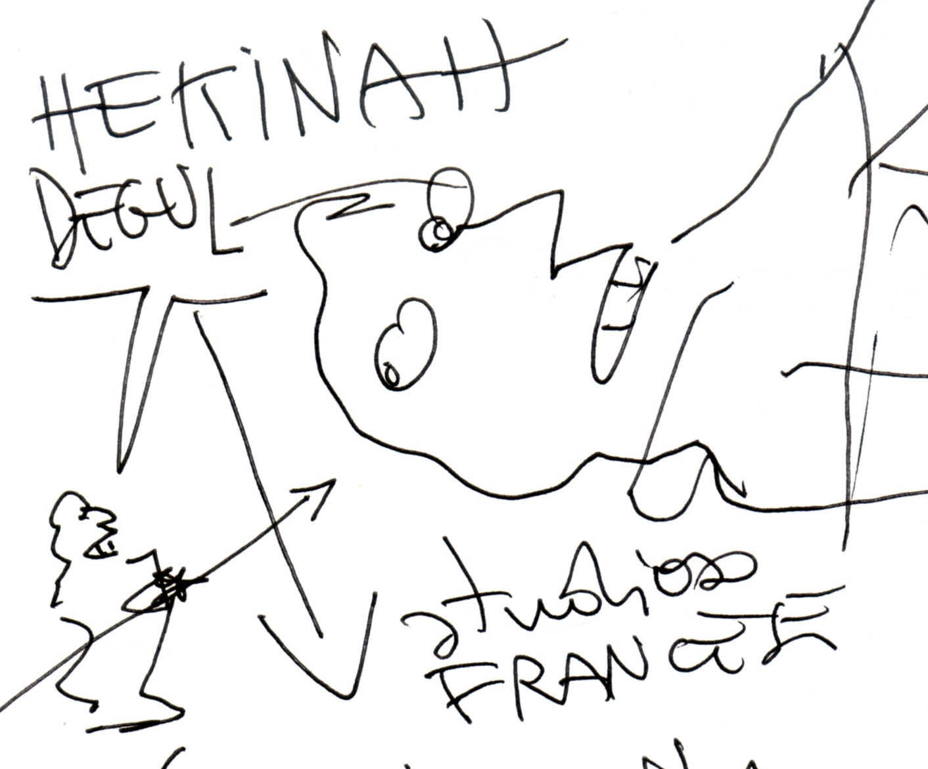

FLORENCE 2009 NOVEMBER
from 16th to 20th

NOVEMBER 16th on Monday
9,30 AM
Cairoli School (Headquarters Office)
Reception of visitors by Headmistress Luciana Marchese
10,30 AM
Vittorio Veneto Primary School
Search in European School
The Comenius inside the different realities (ITALY)
Coordination by Massimo Presciutti
1 PM
Lunch at School
14 PM
Showing of the video
“Inoltrati nella primavera” (“In the springtime”)
Serristori Pre Primary School visit

FREE TIME
6 PM
Bookshop Edison Piazza della Repubblica
The presentation of the project “Happy S.C.I.E.N.C.E.” in public

NOVEMBER 17th on Tuesday
9,30 AM
Vittorio Veneto Primary School
Creativity in European School
The Comenius inside the different realities (BULGARIA)
Coordination by Teodora Valova
BREAK
1 PM
Lunch at School
14 PM
Carducci Secondary School
Showing of the video
“Carducci Ciao” (“Carducci good bye”)
FREE TIME
Afternoon Florence tour
(Pupils in action taking drawings and writings on their notebook)

NOVEMBER 18th on Wednesday
9,30 AM
Vittorio Veneto Primary School
Instruction and Education in European School
The Comenius inside the different realities (POLAND)
Coordination by Danuta Herman
BREAK

1 PM
Lunch at School
14 PM
Musical Linguistic Laboratory in action
(Pupils in action taking drawings and writings on their notebook)
FREE TIME
18 PM
Melbookstore via de’ Cerretani 16r
“Happy S.C.I.E.N.C.E.” public concert
Massimo Presciutti songs with Jamie Marie Lazzara's violin and Mia Cooper voice

NOVEMBER 19th on Thursday
9,30 AM
Vittorio Veneto Primary School
Nature and Culture in European School
The Comenius inside the different realities (ROMANIA)
Coordination by Maria Daniela Lukacs
BREAK
1 PM
Lunch at School
14 PM
Biblioteca dei ragazzi (Children Library) - (Quartiere 1 Comune di Firenze)
Perfumes and memory in the Library
New publishing for children

NOVEMBER 20th on Friday
9,30 AM
National Central Library Florence
“Happy S.C.I.E.N.C.E.” inside the memory machine
comment by Piero Scapecchi
Art exhibition visit
“L’esercizio illegale dell’astronomia” (Max Ernst, Iliazd, Tempel)
“The illegal practice of the astronomy” (Max Ernst, Iliazd, Tempel)

